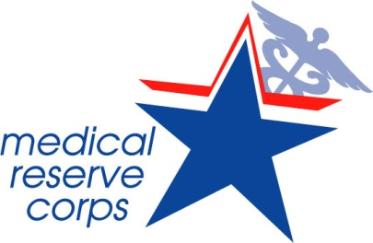
<INSERT MRC UNIT NAME>

Certificate of Appreciation

PRESENTED TO
<First and Last Name>
In recognition of your outstanding contributions in support of the
Medical Reserve Corps Program during <insert event name>.
Your contributions have made a difference.

<Insert Date>
<Insert Name and Job Title>
Volunteers Building Strong, Healthy, and Prepared Communities
Date

